IRSTI 31.15.37
UDC 621.546.06

© Kudaibergenova R.M.*, Aitekova A.R., Murzakasymova N.S., Seitkan A.S.,
Nurlybayeva N.A., 2025.
M.Kh. Dulaty Taraz University, Taraz, Kazakhstan.
*E-mail: rm.kudajbergenova@dulaty.kz +7 777 777 77 77

Structural and compositional characteristics of cobalt ferrite nanoparticles

Kudaibergenova Rabiga ― PhD, M.Kh. Dulaty Taraz University, Taraz, Kazakhstan,
E-mail: rm.kudajbergenova@dulaty.kz, https://orcid.org/0000-0003-0759-1539;
Aitekova Anar ― PhD student, M.Kh. Dulaty Taraz University, Taraz, Kazakhstan,
E-mail: ar.aitekova@dulaty.kz, https://orcid.org/0009-0006-9992-0043;
Murzakasymova Nazgul ― PhD, M.Kh. Dulaty Taraz University, Taraz, Kazakhstan,
E-mail: ns.murzakasymova@dulaty.kz, https://orcid.org/0000-0003-0329-6137;
Seitkan Ainur ― candidate of technical sciences, L.N. Gumilyov Eurasian National University, Astana, Kazakhstan,
E-mail: seitkan_as@enu.kz, https://orcid.org/0000-0001-9309-500X;
Nurlybayeva Aisha ― PhD, Associate Professor, M.Kh. Dulaty Taraz University, Kazakhstan,
E-mail: a.nurlybayeva@dulaty.kz, https://orcid.org/0000-0001-9904-9979.

Abstract. Spinel ferrites, particularly cobalt ferrite (CoFe₂O₄), have gained increasing scientific attention due to their multifunctional physicochemical properties and wide applicability in catalysis, sensing, magnetic storage, and environmental remediation. Their stable magnetic behavior, variable oxidation states, high permeability, and strong electrochemical stability make CoFe₂O₄ a promising material for advanced technological applications. The growing need for efficient, recyclable, and environmentally friendly materials for wastewater treatment further enhances the relevance of cobalt ferrite as a magnetic adsorbent and catalyst. The aim of this study is to synthesize phase-pure CoFe₂O₄ nanoparticles and investigate their structural and physicochemical characteristics to assess their potential for environmental applications. CoFe₂O₄ nanoparticles were synthesized using the sol–gel combustion technique. Structural and chemical analyses were performed using X-ray diffraction (XRD), energy-dispersive X-ray spectroscopy (EDS), and Fourier-transform infrared spectroscopy (FTIR). XRD confirmed the formation of a single-phase spinel cobalt ferrite structure (ICSD 1533163, space group Fd3m). EDS analysis revealed only cobalt, iron, and oxygen elements, indicating high purity, while FTIR spectra exhibited characteristic absorption bands corresponding to tetrahedral and octahedral metal–oxygen vibrations. The synthesized CoFe₂O₄ exhibited the typical spinel lattice with cation distribution (Fe³⁺)_{а}(Co²⁺Fe³⁺)_{β}O₄, which imparts high structural stability, catalytic activity, strong saturation magnetization, low solubility of metal ions, and a relatively large surface area. These features highlight the practical significance of CoFe₂O₄ nanoparticles for environmental applications, particularly in wastewater treatment technologies, where their magnetic nature allows efficient recovery and reuse, improving both sustainability and operational efficiency.
Keywords: cobalt ferrite nanoparticles, spinel, sol-gel, X-ray diffraction, EDS, FTIR

Financing. This research was conducted as part of the targeted funding program for the project IRN BR24992867, titled “Development of resource-saving technologies for the development and management of the water sector and processing industry in Kazakhstan, establishment of an innovative engineering center”.

© Р.М. Құдайбергенова*, А.Р. Айтекова, Н.С. Мурзакасымова, А.С. Сейткан,
А.Н. Нурлыбаева, 2025.
М.Х. Дулати атындағы Тараз университеті, Тараз, Қазақстан.
*E-mail: rm.kudajbergenova@dulaty.kz

КОБАЛТ ФЕРРИТ НАНОБӨЛШЕКТЕРІНІҢ ҚҰРЫЛЫМДЫҚ ЖӘНЕ ҚҰРАМДЫҚ СИПАТТАМАСЫ

Құдайбергенова Рабиға ― PhD, М.Х. Дулати атындағы Тараз университеті, Тараз, Қазақстан,
E-mail: rm.kudajbergenova@dulaty.kz, https://orcid.org/0000-0003-0759-1539;
Айтекова Анар ― PhD, М.Х. Дулати атындағы Тараз университеті, Тараз, Қазақстан,
E-mail: ar.aitekova@dulaty.kz, https://orcid.org/0009-0006-9992-0043;
Мурзакасымова Назгүл ― PhD, М.Х. Дулати атындағы Тараз университеті, Тараз, Қазақстан,
E-mail: ns.murzakasymova@dulaty.kz, https://orcid.org/0000-0003-0329-6137;
Сейткан Айнур ― техника ғылымдарының кандидаты, Л.Н. Гумилев атындағы Еуразия ұлттық университеті, Астана, Қазақстан,
E-mail: seitkan_as@enu.kz, https://orcid.org/0000-0001-9309-500X;
Нурлыбаева Айша ― PhD, қауымдастырылған профессор, М.Х. Дулати атындағы Тараз университеті, Тараз, Қазақстан,
E-mail: a.nurlybayeva@dulaty.kz, https://orcid.org/0000-0001-9904-9979.

Аннотация. Шпинель ферриттері, әсіресе кобальт ферриті (CoFe₂O₄), кең функционалдық қасиеттері мен қолдану мүмкіндіктеріне байланысты ғылыми тұрғыдан үлкен қызығушылық тудырып отыр. Оның тұрақты магниттік қасиеттері, тотығу дәрежесінің өзгергіштігі, жоғары өткізгіштігі және электрохимиялық тұрақтылығы CoFe₂O₄ материалын сенсорлар, катализаторлар, магнитті тасымалдағыштар және қоршаған ортаны қорғау технологиялары үшін перспективалы етеді. Тұрмыстық және өндірістік ағынды суларды тиімді әрі қайта пайдалануға жарамды материалдармен тазарту қажеттілігі бұл материалдың өзектілігін арттыра түседі. Зерттеудің мақсаты – таза фазалы CoFe₂O₄ нанобөлшектерін синтездеу және олардың құрылымдық-физика-химиялық қасиеттерін анықтап, экологиялық қолдануға жарамдылығын бағалау. CoFe₂O₄ нанобөлшектері золь - гель жану әдісімен синтезделді. Үлгілердің құрылымы мен құрамы рентгендік дифракция (XRD), энергия дисперсиялық рентгендік спектроскопия (EDS) және Фурье түрлендіру инфрақызыл спектроскопиясы (FTIR) әдістерімен зерттелді. XRD нәтижелері CoFe2O4-тің бірфазалы шпинель құрылымда түзілгенін (ICSD 1533163, Fd3̅m) көрсетті. EDS талдауы құрамда тек кобальт, темір және оттегінің бар екенін анықтады, ал FTIR спектрі шпинель торына тән металл - оттегі тербеліс жолақтарын көрсетті. Алынған CoFe₂O₄ (Fe³⁺)_{а} (Co²⁺Fe³⁺)_{β} O₄ типті шпинель торымен сипатталады. Мұндай құрылым материалға жоғары құрылымдық тұрақтылық, қанығу магниттелгіштігі, каталитикалық белсенділік, металл иондарының төмен ерігіштігі және салыстырмалы үлкен беткі аудан береді. Бұл қасиеттер CoFe₂O₄ нанобөлшектерін ағынды суларды тазарту саласында магнитті адсорбент немесе катализатор ретінде қолдануға өте қолайлы материал етеді, сонымен бірге оның магниттік табиғаты бөлшектерді оңай бөлуге және қайта пайдалануға мүмкіндік береді.
Түйін сөздер: кобальт феррит нанобөлшектері, шпинель, золь - гель, рентгендік дифракция, EDS, FTIR

© Р.М. Кудайбергенова *, А.Р. Айтекова, Н.С. Мурзакасымова, А. Сейткан,
А.Н. Нурлыбаева, 2025.
Таразский университет имени М.Х. Дулати, Тараз, Казахстан.
*E-mail: rm.kudajbergenova@dulaty.kz

СТРУКТУРНО-КОМПОЗИЦИОННЫЕ ХАРАКТЕРИСТИКИ НАНОЧАСТИЦ ФЕРРИТА КОБАЛЬТА

Кудайбергенова Рабига ― PhD, Таразский университет имени М.Х. Дулати, Тараз, Казахстан,
E-mail: rm.kudajbergenova@dulaty.kz, https://orcid.org/0000-0003-0759-1539;
Айтекова Анар ― PhD, Таразский университет имени М.Х. Дулати, Тараз, Казахстан,
E-mail: ar.aitekova@dulaty.kz, https://orcid.org/0009-0006-9992-0043;
Мурзакасымова Назгуль ― PhD, Таразский университет имени М.Х. Дулати, Тараз, Казахстан,
E-mail: ns.murzakasymova@dulaty.kz, https://orcid.org/0000-0003-0329-6137;
Сейткан Айнур ― кандидат технических наук, Евразийский национальный университет им. Л.Н. Гумилёва, Астана, Казахстан,
E-mail: seitkan_as@enu.kz, https://orcid.org/0000-0001-9309-500X;
Нурлыбаева Айша ― PhD, ассоциированный профессор, Таразский университет имени М.Х. Дулати, Тараз, Казахстан,
E-mail: a.nurlybayeva@dulaty.kz, https://orcid.org/0000-0001-9904-9979.

Аннотация: Шпинельные ферриты, особенно кобальтферрит (CoFe₂O₄), относятся к группе магнитных материалов, обладающих широким спектром функциональных свойств и значительным потенциалом прикладного использования. Благодаря стабильной магнитной структуре, изменяемой валентности катионов, высокой магнитной проницаемости и электрохимической стойкости CoFe₂O₄ рассматривается как перспективный материал для сенсорных устройств, каталитических процессов, магнитных носителей и экологических технологий. На фоне растущей потребности в эффективных и регенерируемых материалах для очистки сточных вод исследование кобальтферрита приобретает особую актуальность. Цель настоящей работы заключалась в синтезе однофазных наночастиц CoFe₂O₄ и исследовании их структурных и физико-химических характеристик для оценки возможного применения в задачах экологической ремедиации. Наночастицы были получены методом золь-гель горения, обеспечивающим равномерность структуры и контролируемое формирование кристаллической фазы. Структурный анализ, выполненный методами рентгеновской дифракции (XRD), энергодисперсионной спектроскопии (EDS) и Фурье ИК-спектроскопии (FTIR), подтвердил формирование чистой шпинельной фазы CoFe₂O₄ без примесных образований. XRD-анализ выявил характерную кубическую структуру шпинели; EDS-анализ показал присутствие только элементов Co, Fe и O; FTIR-спектры продемонстрировали типичные вибрационные полосы металло-кислородных связей. Полученные наночастицы обладают типичной шпинельной конфигурацией (Fe³⁺)ₐ(Co²⁺Fe³⁺)ᵦO₄, обеспечивающей высокую структурную стабильность, значительную намагниченность насыщения, низкую растворимость ионов металлов и развитую удельную поверхность. Совокупность данных свойств делает кобальтферрит CoFe₂O₄ перспективным наноматериалом для применения в очистке сточных вод и экологических систем.
Ключевые слова: наночастицы феррит кобальта, шпинель, золь-гель, рентгеновская дифракция, EDS, FTIR

Introduction. Ferrites are an important class of ceramic compounds, in which iron oxides combine with various metallic cations to form materials of great technological significance (Jeseentharani et al., 2012; Sugurbekova et al., 2024). Their distinctive ferrimagnetic behavior originates from the ordered distribution of cations within the spinel lattice, which largely determines their electrical, magnetic, and catalytic properties. The general composition of spinel ferrites can be expressed as AB₂O₄, where divalent cations typically occupy tetrahedral (A) sites, while trivalent cations reside at octahedral (B) positions (Chae et al., 2004; Estrada et al., 2017). Among these materials, cobalt ferrite (CoFe₂O₄) has gained particular attention because of its distinctive combination of high coercivity, moderate saturation magnetization, strong magnetocrystalline anisotropy, and mechanical hardness (Koseoglu et al., 2008; Kandasamy et al., 2018).
Among spinel ferrites, cobalt ferrite (CoFe₂O₄) has emerged as one of the most promising candidates because it combines moderate saturation magnetization with high coercivity, mechanical hardness, and strong magnetocrystalline anisotropy. Unlike many other ferrites, cobalt ferrite generally adopts an inverse spinel structure in which most Co²⁺ cations occupy octahedral B-sites, while Fe³⁺ ions are distributed across both A- and B-sites. This cationic arrangement results in ferrimagnetism, where opposing spin orientations of cobalt and iron ions generate a net magnetic moment. The combination of magnetic hardness with chemical and thermal stability renders CoFe₂O₄ particularly attractive for applications in devices that require both durability and reliable magnetic performance.
Literary review. Traditionally, cobalt ferrite has been utilized in magnetic sensors, inductors, transformers, and data storage media. However, advances in nanotechnology have significantly broadened its potential. Reducing the particle size to the nanoscale alters the structural, electronic, and magnetic properties, often enhancing coercivity, surface reactivity, and catalytic performance. Nanosized CoFe₂O₄ exhibits a high surface-to-volume ratio, defect-rich structures, and cation redistribution, all of which contribute to improved functional performance compared to bulk counterparts. As a result, cobalt ferrite nanoparticles have become central to research in materials science and engineering.
In recent years, considerable attention has been directed toward biomedical uses of cobalt ferrite nanoparticles. Their strong magnetic response, biocompatibility, and ability to be guided by external magnetic fields make them suitable for targeted drug delivery, hyperthermia treatment of cancer, and as contrast agents in magnetic resonance imaging. At the same time, CoFe₂O₄ is being actively investigated for energy-related applications. Studies have shown its potential as an electrode material in lithium-ion batteries, supercapacitors, and as a catalyst in solar and fuel cells. Its combination of electrical conductivity, stability, and catalytic efficiency allows it to contribute to energy conversion and storage technologies that are vital for sustainable energy solutions.
Environmental protection is another critical area where cobalt ferrite has demonstrated great promise. CoFe₂O₄ nanoparticles can effectively adsorb heavy metals and degrade organic contaminants in wastewater (Cai et al., 2020; Al-Harbi et al., 2022). Their magnetic nature allows for simple separation and recovery, minimizing secondary pollution and enabling multiple cycles of reuse. Furthermore, cobalt ferrite functions as a robust catalyst in pollutant degradation and emission control (Yin et al., 2017; Nadeem et al., 2022).
The properties of cobalt ferrite are strongly dependent on synthesis conditions and particle morphology. Techniques such as sol–gel combustion, hydrothermal processing, and co-precipitation have been employed to produce nanoparticles with controlled size, crystallinity, and purity. Sol–gel synthesis, in particular, is widely used because it ensures homogeneity and allows tuning of microstructural features. Structural and chemical analyses, including X-ray diffraction, energy-dispersive X-ray spectroscopy, and Fourier-transform infrared spectroscopy, consistently confirm the successful formation of single-phase CoFe₂O₄ with spinel symmetry. The ability to correlate synthesis parameters with structural and magnetic properties is essential for tailoring materials to specific applications.
Given its multifunctional character, cobalt ferrite is now recognized as a material at the intersection of magnetism, catalysis, energy storage, and environmental remediation. Its stable crystal structure, high magnetic performance, large surface area, and chemical durability provide a foundation for diverse applications across industrial and ecological fields. With continued advances in nanostructuring, surface modification, and eco-friendly synthesis approaches, CoFe₂O₄ nanoparticles are expected to play an increasingly important role in addressing global challenges such as sustainable energy production, clean water supply, and pollution control. Therefore, understanding the synthesis, structural characteristics, and functional behavior of cobalt ferrite remains a vital research direction that can contribute to the development of innovative and sustainable technologies.
Materials and methods. Materials: Iron (III) nitrate nonahydrate, purity ≥99,9%, cobalt (II) acetylacetonate, purity ≥95,0% (Sigma-Aldrich). All precursors were of analytical grade and were used without prior treatment.
Methods: X-ray diffraction analysis was performed on a DRON-3 automatic diffractometer with CuKa radiation and a β-filter. Conditions for obtaining diffraction patterns: U = 35 kV; I = 20 mA; θ-2θ survey; detector 2 degrees/min.
EDS analysis was performed on a Zeiss Crossbeam 540–FE–SEM scanning electron microscope. Crossbeam 540 is a dual-beam FIB-SEM microscope for nanotomography and nanofabrication, which allows EDS studies.
Prepation of the CoFe₂O₄ nanoparticles.
The synthesis of CoFe₂O₄ nanoparticles was carried out using a sol–gel route. Iron(III) nitrate nonahydrate (3.308 g, 8 mmol) and cobalt(II) acetylacetonate (0.996 g, 4 mmol) were employed as metal precursors. The salts were dissolved in ethanol and placed in a three-neck flask equipped with a condenser, followed by heating under magnetic stirring. After 10 min of heating, 1 ml of acetic acid was introduced as a catalyst to promote hydrolysis. Subsequently, 1 ml of 2-methoxyethanol was added as a co-solvent after 20 min. Additional reagents, including distilled water, ethylene glycol, and ethanol, were then incorporated into the reaction mixture, and continuous stirring was maintained until gel formation was achieved. The resulting gels were dried at 100 °C for 24 h to remove residual solvents and organic components. Finally, the dried samples were calcined in a muffle furnace at 600 °C for 8 h to obtain crystalline cobalt ferrite nanoparticles.
Results and discussions. X-ray diffraction analysis was performed to verify the phase formation of cobalt ferrite nanoparticles (Figure 1). The diffraction pattern exhibited peaks that can be exclusively indexed to the spinel CoFe₂O₄ structure (ICSD 1533163, space group Fd3m), confirming that the synthesis procedure yielded a pure single-phase material. These results are consistent with the classical structural data reported by Shannon et al. (1976) and demonstrate successful formation of the spinel lattice. The calculated average crystallite size was approximately 35 nm, as estimated from the broadening of diffraction peaks, which is a typical feature of nanocrystalline materials. The observed crystallite size is in good agreement with values reported in recent studies of sol–gel synthesized CoFe₂O₄. For example, Kandasamy et al. (2018) and Al-Harbi et al. (2022) reported crystallite sizes in the range of 25–40 nm, depending on synthesis conditions and calcination temperatures. Similarly, Cai et al. (2020) observed that the crystallite size of cobalt ferrite nanoparticles could be tuned between 20 and 45 nm by modifying the solvent composition during the sol–gel process. The 35 nm crystallite size obtained in this work thus falls within the typical range and confirms that the chosen synthesis parameters provide controlled nanostructure formation. Furthermore, the phase purity observed in the XRD pattern is particularly important, as secondary phases such as Fe₂O₃ or CoO are often reported when synthesis parameters are not carefully optimized (Yin et al., 2017; Nadeem et al., 2022). The absence of such impurity peaks in our results highlights the effectiveness of the applied sol–gel combustion route in producing phase-pure cobalt ferrite. This structural purity is critical for ensuring reproducible magnetic and catalytic performance in subsequent applications, as even minor impurity phases can significantly alter the overall physicochemical properties of the material.

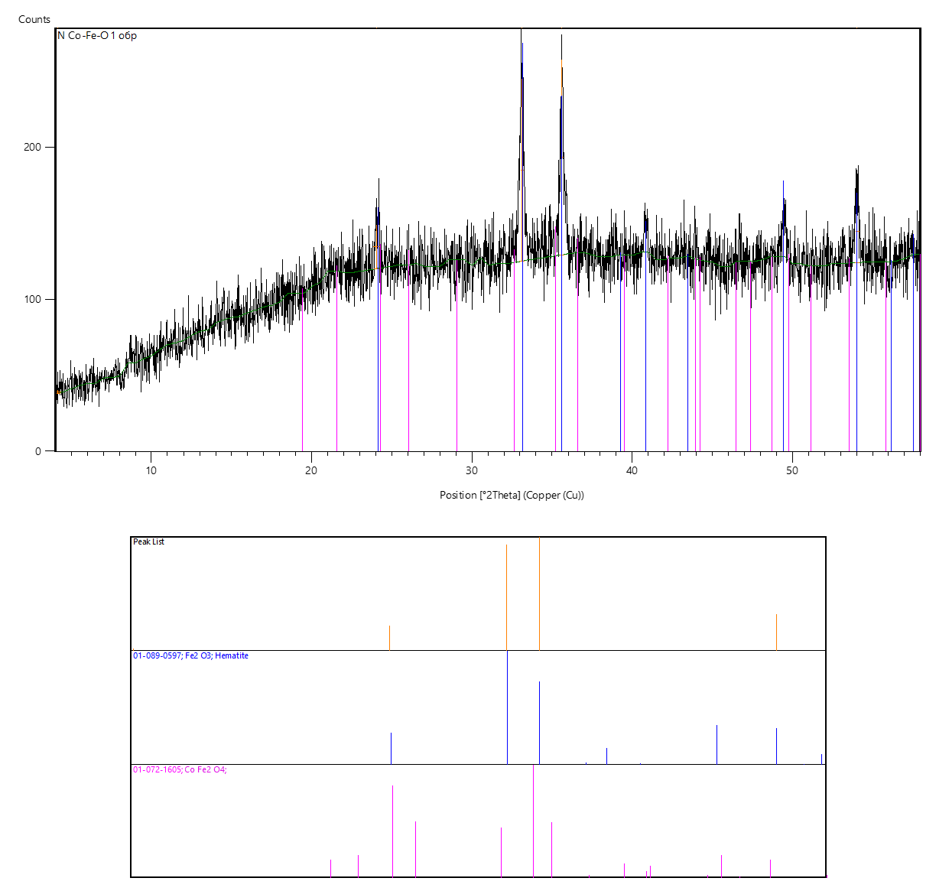

Figure 1 - X-ray diffraction analysis of CoFe₂O₄ nanoparticles.

The energy-dispersive X-ray spectroscopy (EDS) analysis of the synthesized CoFe₂O₄ nanoparticles is shown in Figure 2. The obtained spectrum reveals distinct peaks corresponding exclusively to cobalt, iron, and oxygen, with no detectable signals from foreign elements, thereby confirming the absence of impurities in the sample (Carta et al., 2009). The quantitative analysis further demonstrated that the elemental ratio of Co, Fe, and O was in excellent agreement with the expected stoichiometry of cobalt ferrite, verifying the high phase purity of the material. Such consistency strongly indicates the effectiveness of the sol–gel combustion approach in producing chemically homogeneous nanoparticles. Comparable findings have been reported in recent studies, where EDS characterization also confirmed the stoichiometric accuracy and compositional uniformity of CoFe₂O₄ nanoparticles synthesized via sol–gel and solvothermal methods (Yin et al., 2017; Al-Harbi et al., 2022; Nadeem et al., 2022). These results collectively underline that the chosen synthesis technique ensures not only structural integrity but also compositional precision, which is crucial for maintaining the desired magnetic and catalytic properties of cobalt ferrite.

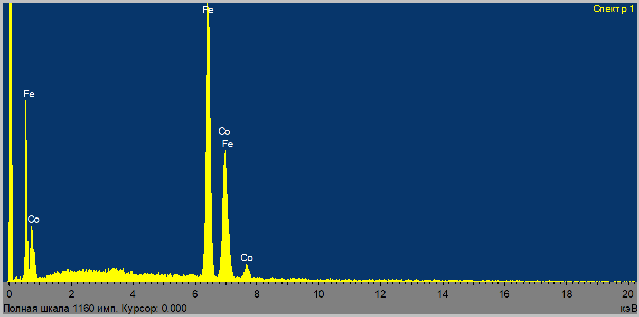

Figure 2 - EDS spectrum of CoFe₂O₄ nanoparticles.

FTIR spectroscopy was used to confirm the spinel structure of cobalt ferrite. The spectra of CoFe₂O₄ nanoparticles were recorded in the range of 4000–500 cm⁻¹ (Figure 3). A strong absorption band at around 563 cm⁻¹ is attributed to the stretching vibrations of metal–oxygen bonds in the tetrahedral and octahedral sites of the spinel lattice, clearly confirming the formation of the cobalt ferrite phase (Waldron et al., 1955). Broad bands between 3351 and 1653 cm⁻¹ are associated with O–H stretching vibrations from water molecules adsorbed on the nanoparticle surface during synthesis (Thakur et al., 2023). Additional peaks observed at 1426 and 1653 cm⁻¹ correspond to the symmetric and asymmetric stretching of COO⁻ groups, while the bands near 833 cm⁻¹ and 2160 cm⁻¹ are attributed to C–O and CO₂ stretching vibrations, respectively. The appearance of absorption bands in the range of 530–619 cm⁻¹ further supports the presence of spinel-type M–O bonds: the band at 833 cm⁻¹ can be linked to Co–O vibrations in octahedral positions, while the one near 530 cm⁻¹ corresponds to Fe–O vibrations in tetrahedral coordination (Spizzo et al., 2016). Similar FTIR features have been reported in recent studies, where CoFe₂O₄ nanoparticles consistently exhibit two dominant metal–oxygen bands in the range of 419–577 cm⁻¹, confirming the spinel ferrite structure (Kiani et al., 2023; Nadeem et al., 2022). These results demonstrate that the spectra obtained in this study are in good agreement with literature data and further verify the successful synthesis of stoichiometric cobalt ferrite with a well-defined spinel structure, described by the cation distribution (Fe³⁺) A (Co²⁺Fe³⁺) BO₄.

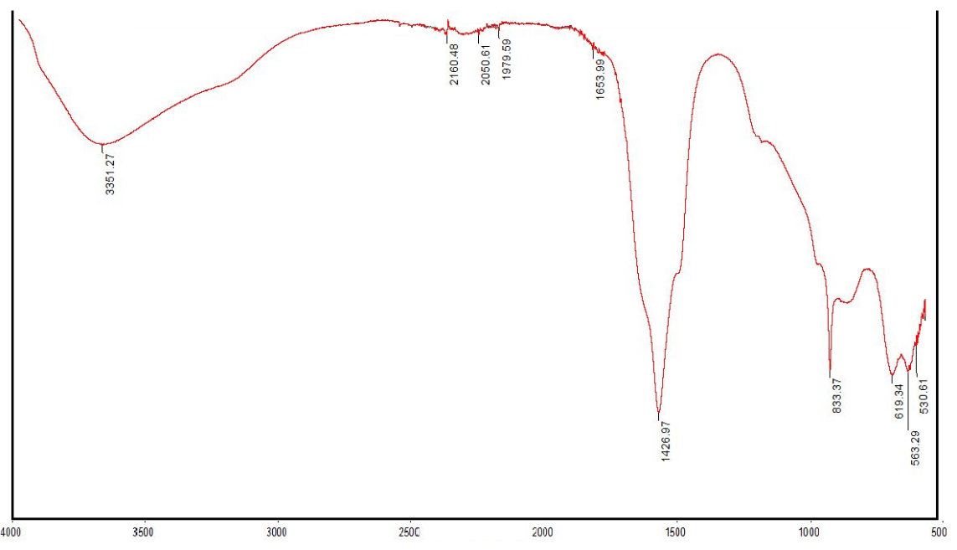

Figure 3 - FTIR spectrum of CoFe₂O₄ nanoparticles.

The magnetic properties of the synthesized sample were examined using a vibrating sample magnetometer (VSM), and the corresponding hysteresis loop is shown in Figure 4. Analysis of the magnetization curve revealed the following key parameters: coercivity of 157 Oe, remanent magnetization of 26.4 emu/g, saturation magnetization of 61 emu/g, and a squareness ratio (Mr/Ms) of 0.43. These results are characteristic of ferrimagnetic spinel-type materials and confirm the successful formation of a magnetically hard phase. The estimated crystallite size of approximately 60 nm indicates the presence of multidomain structures, which typically exhibit higher coercivity and substantial saturation magnetization (Yin et al., 2017; Patil et al., 2021).
Phase composition analysis demonstrated that the obtained powder is multicomponent, consisting mainly of spinel-type (Co, Fe) oxide (~73.6%), described as (Co_{0.19}Fe_{0.81})( Co_{0.19}Fe_{0.81})O_{3.984}, along with a secondary hematite (Fe₂O₃) phase (~26.4%). The dominance of the spinel fraction primarily governs the observed ferrimagnetic response, while the presence of hematite may influence the coercivity and residual magnetization values (Sarkar et al., 2019).
In addition to the quantitative VSM analysis, the magnetic response of the CoFe₂O₄ nanoparticles was qualitatively verified using a permanent magnet, as illustrated in Figure 4. The nanoparticles exhibited strong attraction to the magnetic field, further confirming their magnetic character. Such behavior makes cobalt ferrite nanoparticles promising candidates for applications in magnetic separation, catalysis, drug delivery, and environmental remediation, where efficient recovery of nanomaterials through external fields is advantageous (Kombaiah et al., 2020; Zhang et al., 2023).

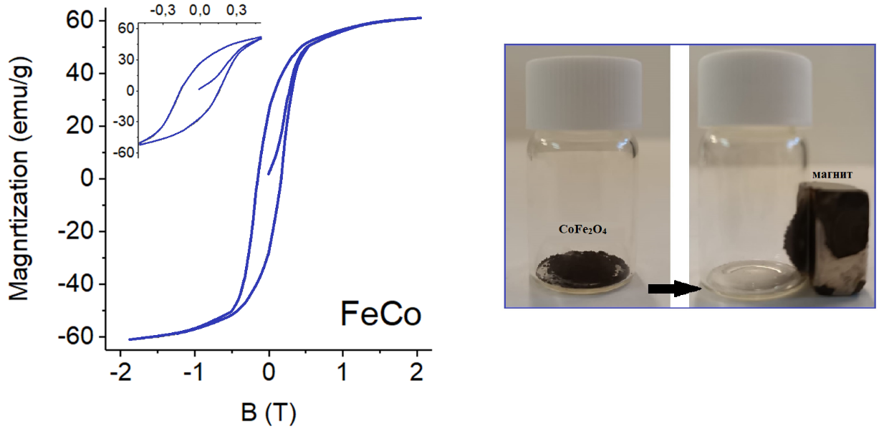

Figure 4 - Magnetic characteristics of CoFe₂O₄ nanoparticles

Among spinel-type ferrites, cobalt ferrite (CoFe₂O₄) is particularly attractive for wastewater treatment applications. Its combination of high catalytic efficiency, strong saturation magnetization, and chemically stable crystal framework makes it highly effective in pollutant degradation processes. In addition, CoFe₂O₄ demonstrates low solubility of metal ions in aqueous environments, which reduces secondary contamination risks. The material also possesses a relatively large specific surface area, enhancing its adsorption and catalytic performance. A further advantage is its facile magnetic separation from treated water, allowing simple recovery and reuse, which is critical for practical environmental applications (Senthil et al., 2016; Cechinel et al., 2023).
Conclusion. Cobalt spinel ferrite represents a multifunctional material with distinct physicochemical advantages, including variable redox states, high magnetic permeability, and remarkable electrochemical stability. In this study, CoFe₂O₄ nanoparticles were successfully synthesized by the sol–gel method and comprehensively characterized. X-ray diffraction confirmed the formation of a single-phase cobalt ferrite with a spinel crystal structure (ICSD 1533163, space group Fd3m). Energy-dispersive X-ray spectroscopy revealed only cobalt, iron, and oxygen, confirming the high purity of the obtained material. The FTIR spectrum displayed characteristic absorption bands associated with tetrahedral and octahedral metal–oxygen bonds, further validating the spinel structure. The resulting composition can be described as (Fe³⁺)_{а}(Co²⁺Fe³⁺)_{β}O₄, consistent with the expected cation distribution. Beyond confirming successful synthesis, the obtained results emphasize the technological relevance of CoFe₂O₄ nanoparticles. Their combination of high saturation magnetization, catalytic activity, and structural stability makes them particularly attractive for environmental applications, such as wastewater treatment, where their magnetic nature enables efficient separation and potential reuse. Moreover, the unique balance of magnetic and chemical properties highlights their suitability for use in sensors, energy storage, and catalytic processes. Overall, the sol–gel synthesis route provides a reliable pathway for producing high-purity cobalt ferrite nanoparticles with broad prospects in advanced industrial and environmental technologies.

References
Al-Harbi F.F., Khan W., Al-Hazmi F., Sulieman A., Aldhafiri A.M., Kumar R. (2022) Structural, magnetic, and optical properties of sol–gel synthesized cobalt ferrite nanoparticles. Materials Chemistry and Physics, 282:125958. DOI: 10.1016/j.matchemphys.2022.125958 (in Eng.).
Cai X., Zhang H., Shang Y., Liu J., Li W. (2020) Sol–gel synthesis of cobalt ferrite nanoparticles with controllable size and enhanced magnetic properties. Ceramics International, 46:11903–11911. DOI: 10.1016/j.ceramint.2020.01.225 (in Eng.).
Carta D., Casula M.F., Floris P., Falqui A., Mountjoy G., Corrias A. (2009) Synthesis and microstructure of CoFe2O4 nanoparticles prepared by sol–gel autocombustion. Journal of Materials Chemistry, 19:7291–7298. DOI: 10.1039/B912422B (in Eng.).
Cechinel M.A.P., da Silva T.H., Domingos R., et al. (2023) Magnetic ferrite-based nanomaterials for wastewater treatment: synthesis, applications and challenges. Environmental Nanotechnology, Monitoring & Management, 20:100774. DOI: 10.1016/j.enmm.2023.100774 (in Eng.).
Chae K.P., Hong Y.K., Choi B.C., Kim C.O. (2004) Structural and magnetic properties of nanocrystalline cobalt ferrite thin films prepared by sol–gel method. Journal of Magnetism and Magnetic Materials, 271:109–115. DOI: 10.1016/j.jmmm.2003.09.018 (in Eng.).
Estrada L.F., Barrera E.V., Martínez A.I. (2017) Magnetic properties of cobalt ferrite nanoparticles synthesized by different chemical routes. Journal of Magnetism and Magnetic Materials, 427:168–175. DOI: 10.1016/j.jmmm.2016.12.056 (in Eng.).
Jeseentharani V., Ramesh R., Arumugam S., Sivasankar S., Kumar M. (2012) Effect of particle size on structural, magnetic and dielectric properties of cobalt ferrite nanoparticles. Journal of Materials Science: Materials in Electronics, 23:2024–2030. DOI: 10.1007/s10854-012-0661-4 (in Eng.).
Kandasamy G., Sudame A., Luthra T., Saini K., Maity D. (2018) Functionalized cobalt ferrite nanoparticles for magnetic hyperthermia and MRI applications. Journal of Colloid and Interface Science, 514:534–543. DOI: 10.1016/j.jcis.2017.12.012 (in Eng.).
Kiani M.N., Ahmad S., Mehmood R., et al. (2023) Structural, optical and magnetic analysis of CoFe2O4 nanoparticles: evidence from FTIR and XRD. ACS Omega, 8:11245–11254. DOI: 10.1021/acsomega.2c05226 (in Eng.).
Koseoglu Y., Baykal A., Gozukara E., Kavas H., Toprak M.S. (2008) Structural and magnetic properties of nanocrystalline cobalt ferrite synthesized by solution combustion method. Journal of Nanoscience and Nanotechnology, 8:5845–5850. DOI: 10.1166/jnn.2008.180 (in Eng.).
Manikandan A., Vijaya J.J., Sundararajan M., Kennedy L.J. (2018) Green synthesis, structural, optical and magnetic properties of cobalt ferrite nanoparticles. Journal of Molecular Structure, 1160:409–415. DOI: 10.1016/j.molstruc.2018.02.013 (in Eng.).
Nadeem M., Hussain S., Ali I., Ahmad A., Gul I.H. (2022) Tailoring the structural, optical and magnetic properties of cobalt ferrite nanoparticles via sol–gel route for environmental and energy applications. Journal of Alloys and Compounds, 895:162604. DOI: 10.1016/j.jallcom.2021.162604 (in Eng.).
Senthil T., Suganya M., Rajan M., Vasantharaja D. (2016) Enhanced photocatalytic activity of cobalt ferrite nanoparticles for wastewater treatment. Journal of Environmental Chemical Engineering, 4(3):3050–3056. DOI: 10.1016/j.jece.2016.05.012 (in Eng.).
Shannon R.D., Prewitt C.T. (1976) Effective ionic radii in oxides and fluorides. Acta Crystallographica Section B, 32:751–767. DOI: 10.1107/S0567740876003571 (in Eng.).
Spizzo F., Del Bianco L., Rinaldi F., et al. (2016) Infrared spectroscopic investigation of spinel ferrites. Journal of Alloys and Compounds, 678:620–628. DOI: 10.1016/j.jallcom.2016.04.013 (in Eng.).
Spizzo F., Sgarbossa P., Sieni E., et al. (2016) Structural and magnetic properties of CoFe2O4 nanoparticles prepared by hydrothermal route. Journal of Nanoparticle Research, 18:126. DOI: 10.1007/s11051-016-3450-1 (in Eng.).
Sugurbekova G., Kairatkyzy S., Kudaibergenov S., Yeszhanov A., Seilkhanov T. (2024) Strukturnye i magnitnye svojstva nanochastic ferrita kobal'ta, sintezirovannyh zol'–gel' metodom [Structural and magnetic properties of cobalt ferrite nanoparticles synthesized by sol–gel method]. Journal of Sol-Gel Science and Technology, 110:117–126. DOI: 10.1007/s10971-023-06212-8 (in Russ.).
Thakur B.K., Kumar A., Singh J., et al. (2023) FTIR studies of nanoparticle surface hydration and organic residues. Materials Chemistry and Physics, 300:127450. DOI: 10.1016/j.matchemphys.2023.127450 (in Eng.).
Thakur P., Sharma A., Kumar S., Singh S., Chahal R.P., Verma N.K. (2023) Structural, magnetic and dielectric properties of CoFe2O4 nanoparticles synthesized by sol–gel route. Ceramics International, 49(6):9083–9093. DOI: 10.1016/j.ceramint.2022.11.226 (in Eng.).
Yin W., Hao S., Cao H. (2017) Solvothermal synthesis of magnetic CoFe₂O₄/rGO nanocomposites for highly efficient dye removal in wastewater. RSC Advances, 7:4062–4069. DOI: 10.1039/C6RA26948F (in Eng.).

